Texas Manual on Uniform Traffic Control Devices – Signage on Low Volume Roads
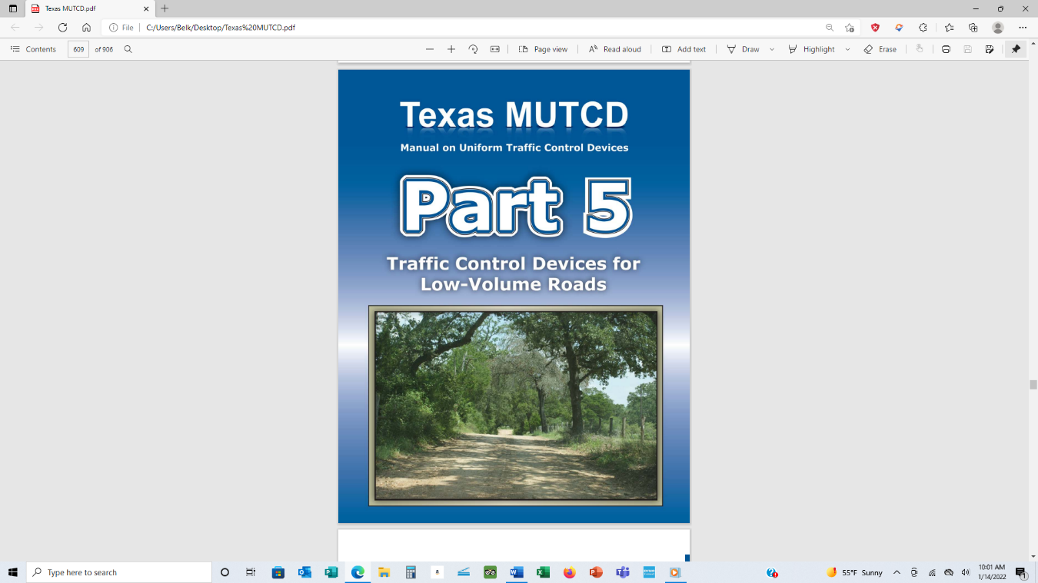
Many cities and counties are surprised when they learn that the signs they use on their roads are subject to the Texas Manual on Uniform Traffic Control Devices (TMUTCD) provisions. You simply cannot purchase signs from a catalog that are not TMUTCD compliant and post them. You can, but you subject your city or county to liability for not following the standards required by the state of Texas. Let’s look at the provisions in the TMUTCD that you must follow if your roadway is verified at 400 AADT or less (refer to Tailgate Talk on the TMUTCD Overview for low volume roads).

Design Standards

Section 5A.03 Design
Standard: 01 Traffic control devices for use on low-volume roads shall
be designed in accordance with the provisions contained in Part 5, and where required, in other applicable Parts of this Manual.
02 The typical sizes for signs and plaques installed on low-volume roads shall be as shown in Table 5A-1. The sizes in the minimum column shall only be used on low-volume roads where the 85th-percentile speed or posted speed limit is less than 35 mph.

For the brevity of this Tailgate Talk, Table 5A-1 in its entirety is not provided however it is found on pages 554 & 555 of the TMUTCD. An extracted sample is shown here for reference.
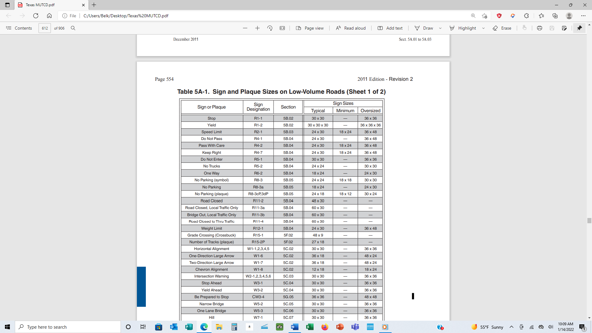

Section 5A.03 Standard continued:
05 All signs shall be retroreflective or illuminated to show the same shape and similar color both day and night, unless specifically stated otherwise in other applicable Parts of this Manual. The requirements for sign illumination shall not be considered to be satisfied by street, highway, or strobe lighting.
06 All markings shall be visible at night and shall be retroreflective unless ambient illumination provides adequate visibility of the markings.

Parts 05 and 06 address the visibility of signs during the day and night. Often, signs will appear completely legible during the day, but they cannot be read or seen at night. The TMUTCD requires periodically checking signs to ensure they are visible at night. The picture of stop signs is a prime example of precisely the same signs during the day and then again at night. Imagine driving down a road you’re unfamiliar with and coming upon one of these stop signs, and all you see is a dark shape. It sets up a liability issue if an accident occurs.
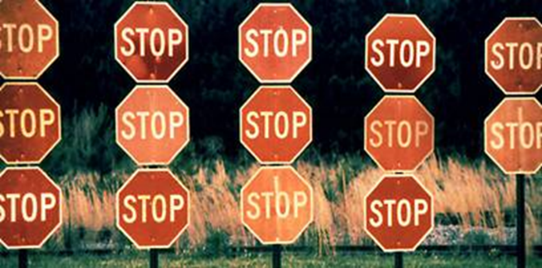
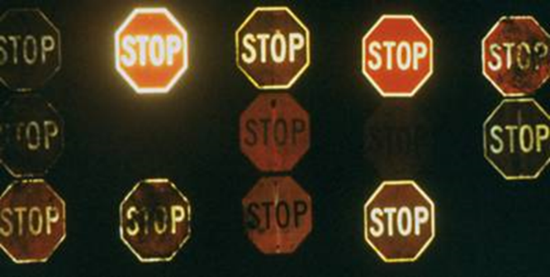
Day View

Night View

Same group
of stop signs

Image courtesy of the Federal Highway Administration
Image courtesy of the Federal Highway Administration

Section 5A.04 Placement
Standard:
01 Except as provided in Paragraph 3, the traffic control devices used on low-volume roads shall be placed and positioned in accordance with the lateral, longitudinal, and vertical placement provisions contained in Part 2 and other applicable Sections of this Manual.
Guidance:
02 The placement of warning signs should comply with the guidance contained in Section 2C.05 and other applicable Sections of this Manual.
Option:
03 A lateral offset of not less than 2 feet from the roadway edge to the roadside edge of a sign may be used where roadside features such as terrain, shrubbery, and/or trees prevent lateral placement in accordance with Section 2A.19.

Notice in Option 03 above that is highlighted, this provision is used many times by cities and counties due to the availability of right-of-way (ROW) to place signs. However, if the ROW is unavailable, standard placements should be followed.

Standard:
04 If located within a clear zone, post-mounted sign supports shall be yielding, breakaway, or shielded with a longitudinal barrier or crash cushion as required in Section 2A.19

Notice in Option 04 above that is highlighted, supports should be yielding, breakaway, or shielded. This means you cannot place sign supports buried in concrete or other attempts to reduce vandalism. The point here is to provide the support that will give way in a crash and not further impact a vehicle and its occupants.

Chapter 5 B. Regulatory Signs

Section 5B.02 STOP and YIELD Signs (R1-1 and R1-2)
Guidance:
01 STOP (R1-1) and YIELD (R1-2) signs (see Figure 5B-1) should be considered for use on low-volume roads where engineering judgment or study, consistent with the provisions of Sections 2B.04 to 2B.10, indicates that either of the following conditions applies:
A. An intersection of a less-important road with a main road where application of the normal right-of-way rule might not be readily apparent.
B. An intersection that has restricted sight distance for the prevailing vehicle speeds

In 5B.02 01 Guidance, the key is engineering judgment. Unless you are a professional engineer licensed in Texas, your personal judgment cannot be used. Always seek the help of a professional and not set up a liability situation!

